Project Design Phase-I
Solution Architecture

Date | 01 November 2026
Team ID | NA
Project Name | Electric Vehicle Market Performance & Insights
Maximum Marks | 4 Marks

Solution Architecture:
Solution architecture is a complex process – with many sub-processes – that bridges the gap between business problems and technology solutions. Its goals are to:
- Find the best tech solution to solve existing business problems.
- Describe the structure, characteristics, behavior, and other aspects of the software to project stakeholders.
- Define features, development phases, and solution requirements.
- Provide specifications according to which the solution is defined, managed, and delivered.

Solution Architecture Diagram:
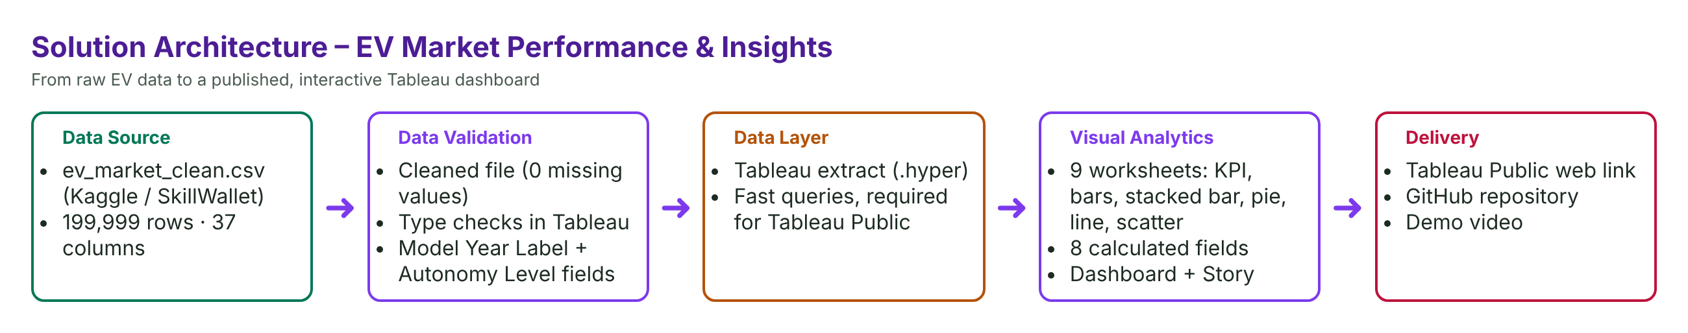

Component Description Table
Component Name | Description / Role in Architecture | Technology Used
Data Source | Cleaned EV dataset ev_market_clean.csv (199,999 rows, 37 columns) | CSV (Kaggle / SkillWallet)
Data Preparation | Duplicates removed, missing values filled; type checks | Cleaned CSV + Tableau Data Source tab
Data Layer | Stores the data as a fast extract | Tableau extract (.hyper)
Analytics | 8 calculated fields, SUM/AVG/COUNT aggregations, shared filters | Tableau Desktop
Visualisation | 9 worksheets, dashboard with KPIs + 4 charts, Story | Tableau Desktop / Public
Delivery | Public dashboard link, files and documentation, demo video | Tableau Public, GitHub, Google Drive

